**Laboratory -7.1 -: Interface and Inheritance**

# Task 1: Open A.java program in your editor and run the file.

1. Output: A screen shot of a computer

   Description automatically generated
2. UML:
   1. 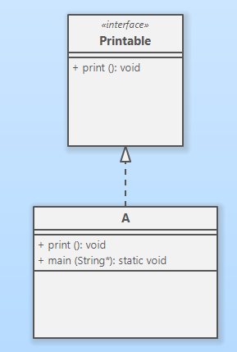

# Task 2: Open B.java program in your editor and run the file.

1. Output: 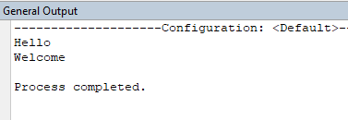

Here, multiple interfaces (two) implemented in a single class B.

1. UML Diagram: 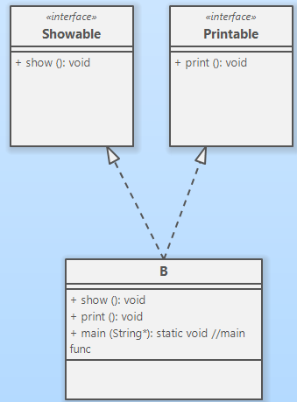
2. After commenting out the show() method, this is the error showing in jCreator . 

As we are going to implement the Showable interface inside the class B, then we must have to implement all its fields and functions. Otherwise, it will give us error. Means, we must have to define the function body.

# Task 3: Interfaces can also hold the Inheritance properties. Open the C.java program in your editor and run the file.

1. Output: 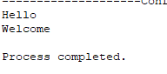 As Showable interface inherit Printable interface via extends keyword. So, on that time whatever the function or properties have the Printable interface, it will be the part or property of the Showable interface. So, when class C implements only Showable interface, it has the Printable properties as well. That is why both print() and show() method implemented.
2. UML Diagram: 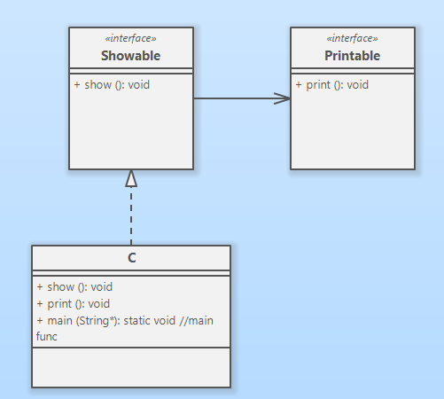

Md. Alamin

21303134.